Supplementary Materials - Distribution, abundance, and health indicators of the critically endangered coral species Acropora cervicornis in Los Roques National Park, 2014.

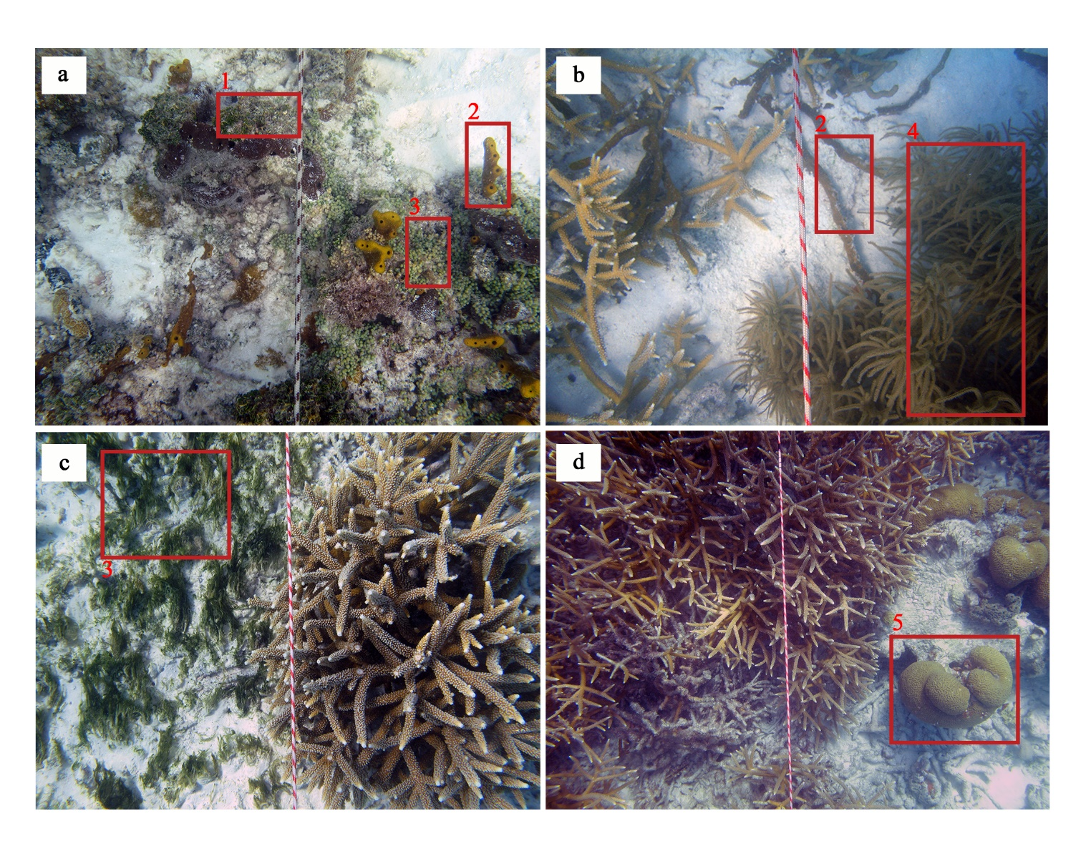
Supplementary material 1. Benthic groups

Supplementary material 1. Example images of general benthic groups across different locations (a-d). 1: Halimeda sp.; 2: Sponges; 3: Macroalgae; 4:Octocoral; 5: Scleractinian.

Supplementary material 2. Species saturation curves.
Species saturation curves to determine the number of points to be analyzed on each transect to estimate community structure and biotic and abiotic cover. The curves were done in 23 photomosaics (n = 44).
https://github.com/Stephanocoenia/cervicornisLR/tree/main/supplements

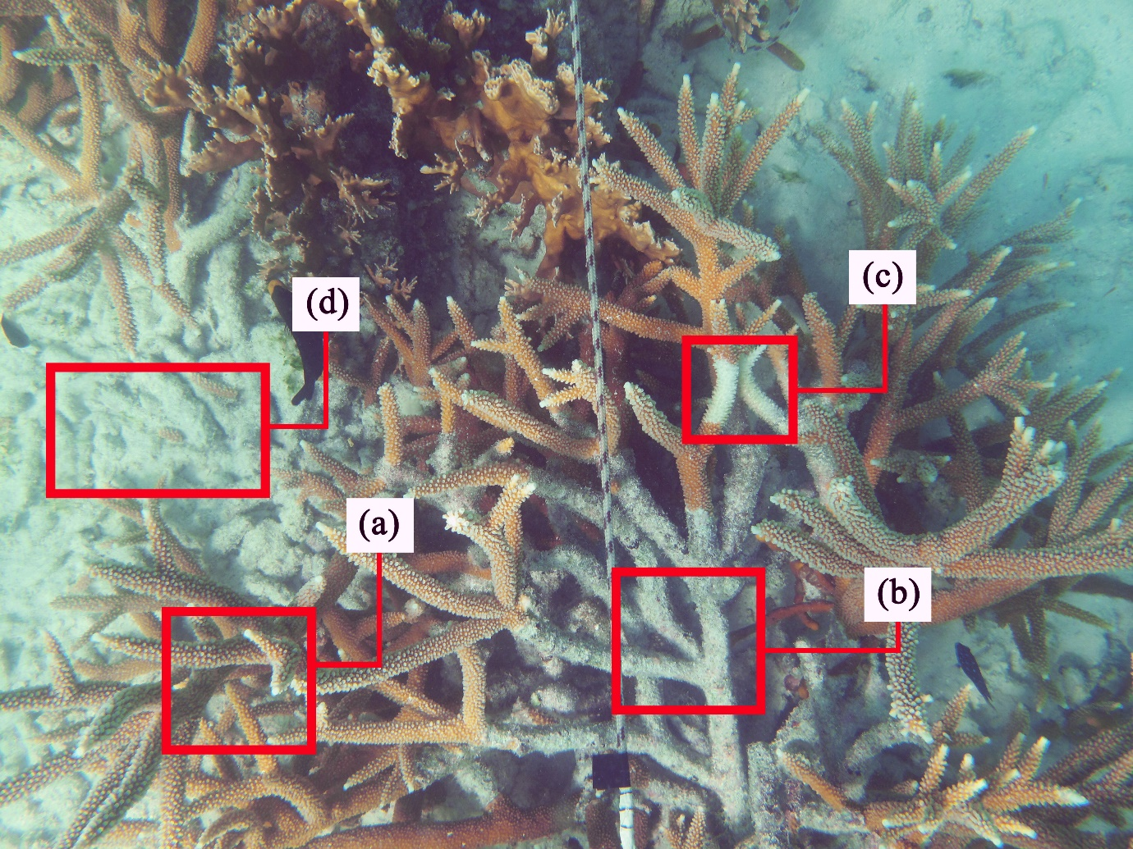
Supplememtary material 3. Health status determination

Supplementary material 3. Visual examples of Acropora cervicornis thicket’s health indicators. (a) A. cervicornis live tissue; (b) A. cervicornis dead tissue; (c) tissue with white band disease; (d) coral rubble.

