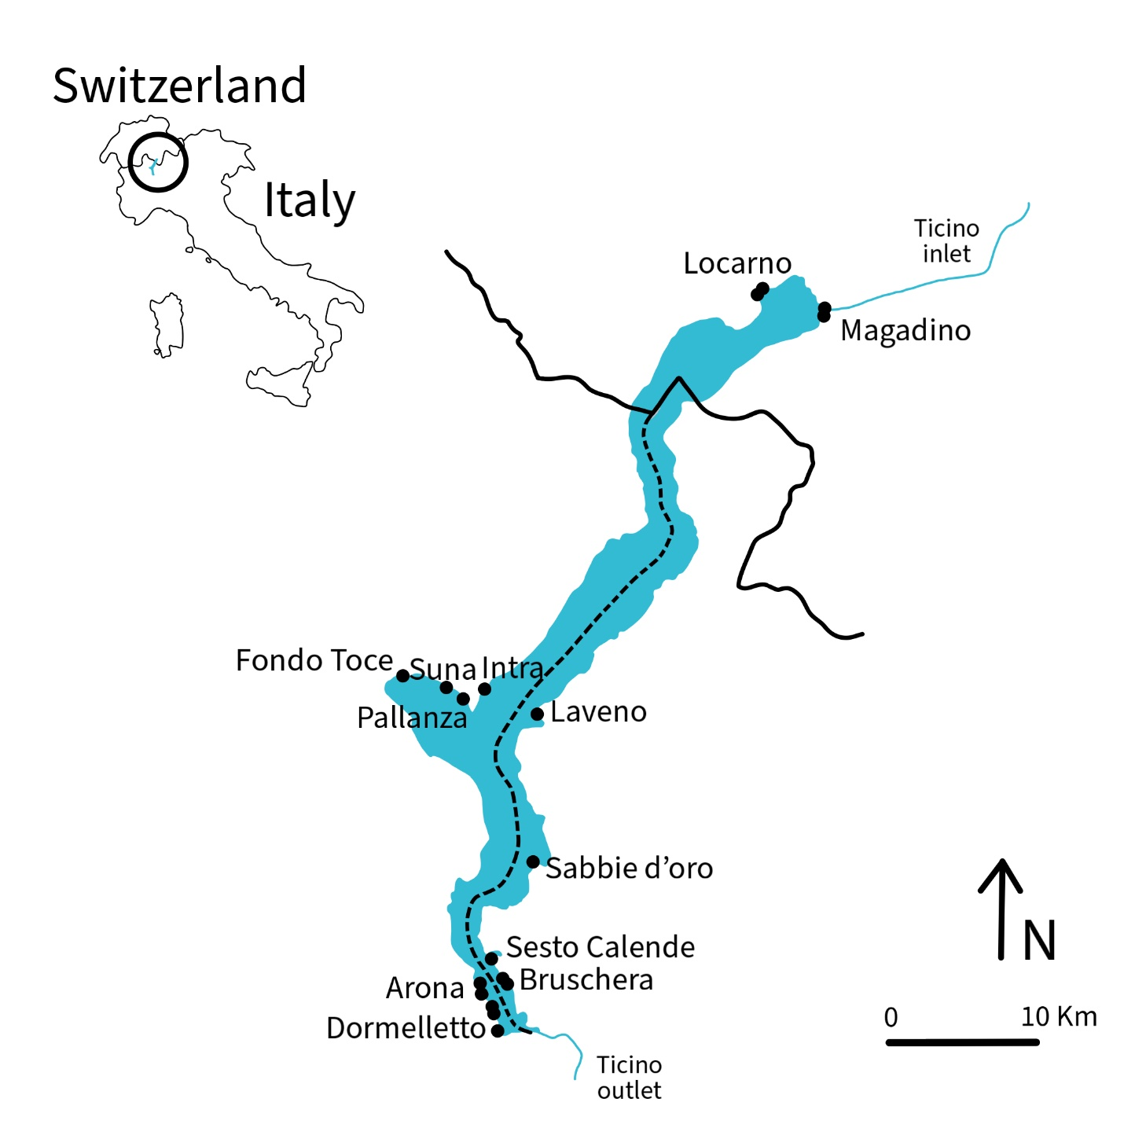
Figure 1. Map of sampling sites along the shores of Lake Maggiore, with the inset indicating the localisation of the lake between Italy and Switzerland.
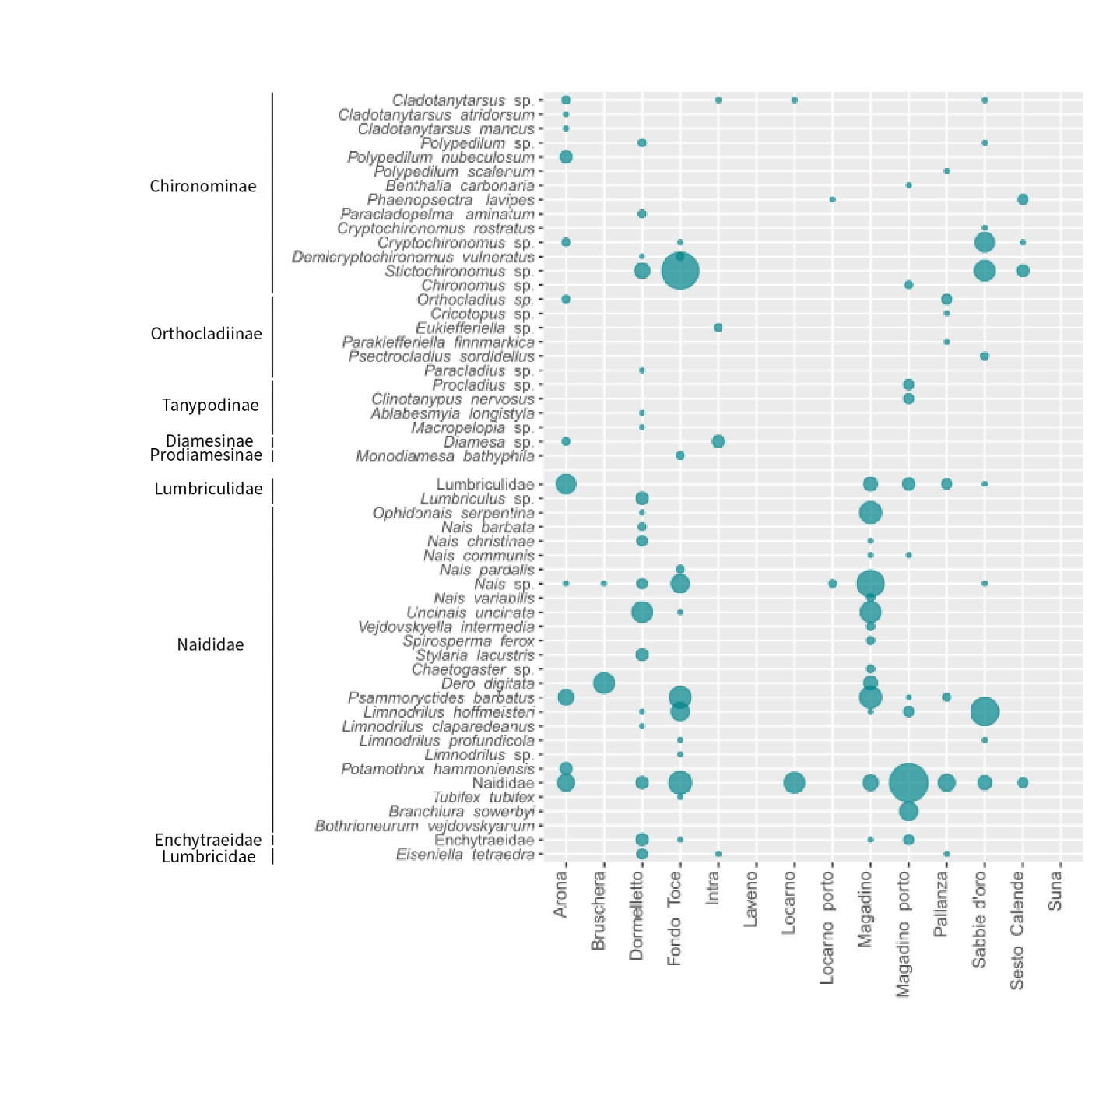
Figure 2. Abundance of individuals of identified taxa of chironomid larvae, divided by subfamilies, and oligochaetes, divided by families. Circle size is proportional to individual abundance in each site.
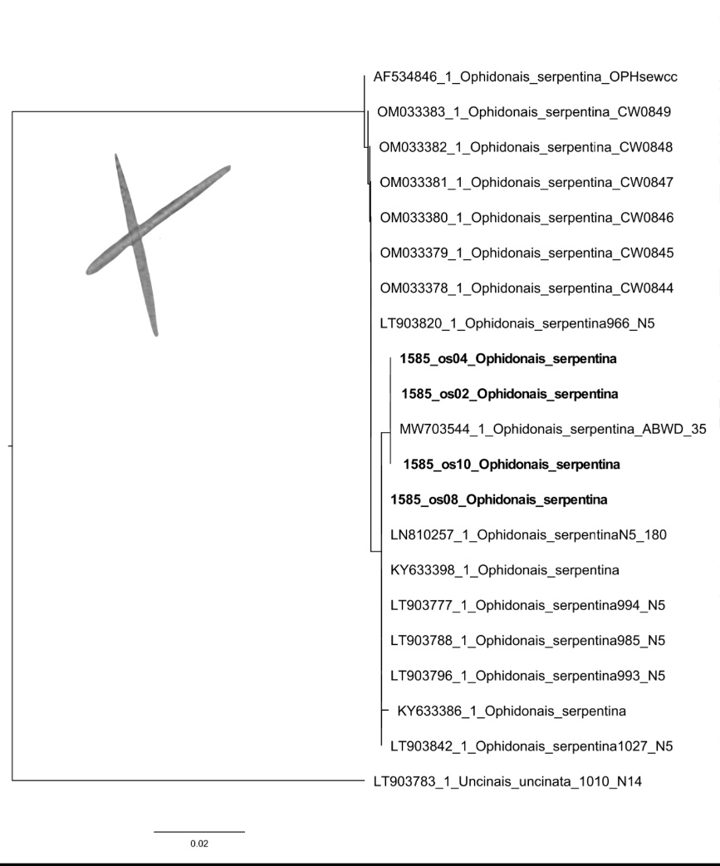
Figure 3. Maximum likelihood phylogenetic tree for the species Ophidonais serpentina, including sequences from GenBank and Uncinais uncinata as an outgroup. The sequences from Lake Maggiore are shown in bold. The image shows the characteristic dorsal stick-shaped chaetae.

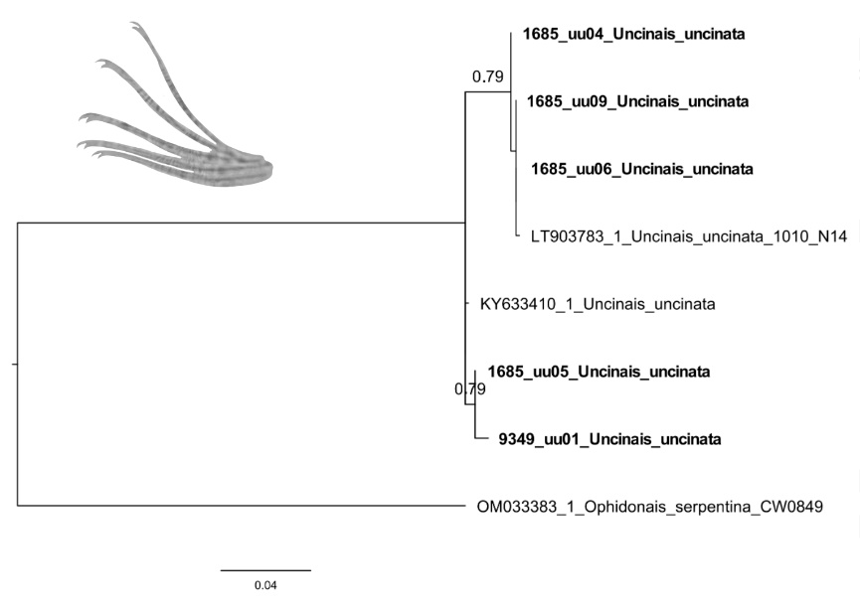
Figure 4. Maximum likelihood phylogenetic tree for the species Uncinais uncinata, including sequences from GenBank and Ophidonais serpentina as an outgroup. The sequences from Lake Maggiore are shown in bold. The image represents the ventral anterior bifid chaetae.

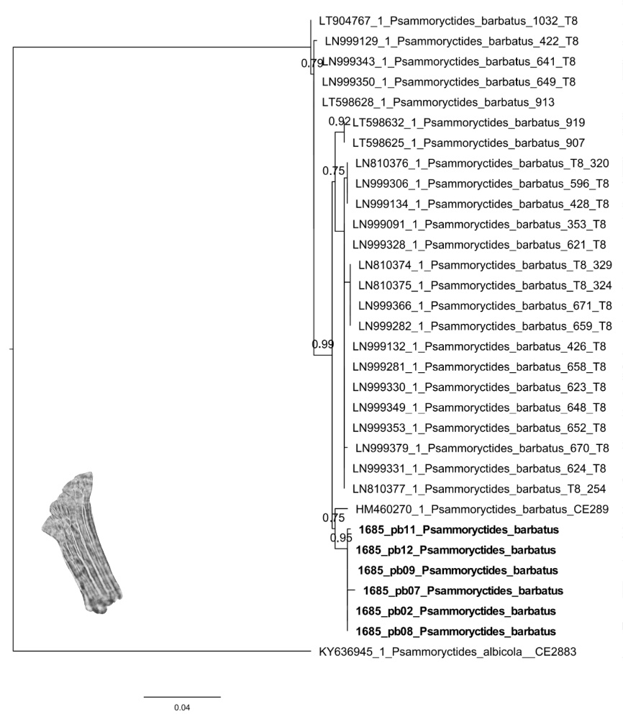
Figure 5. Maximum likelihood phylogenetic tree for the species Psammoryctides barbatus, including sequences from GenBank and Psammoryctides albicola as an outgroup. The sequences from Lake Maggiore are shown in bold. The image represents fan-shaped dorsal chaetae.
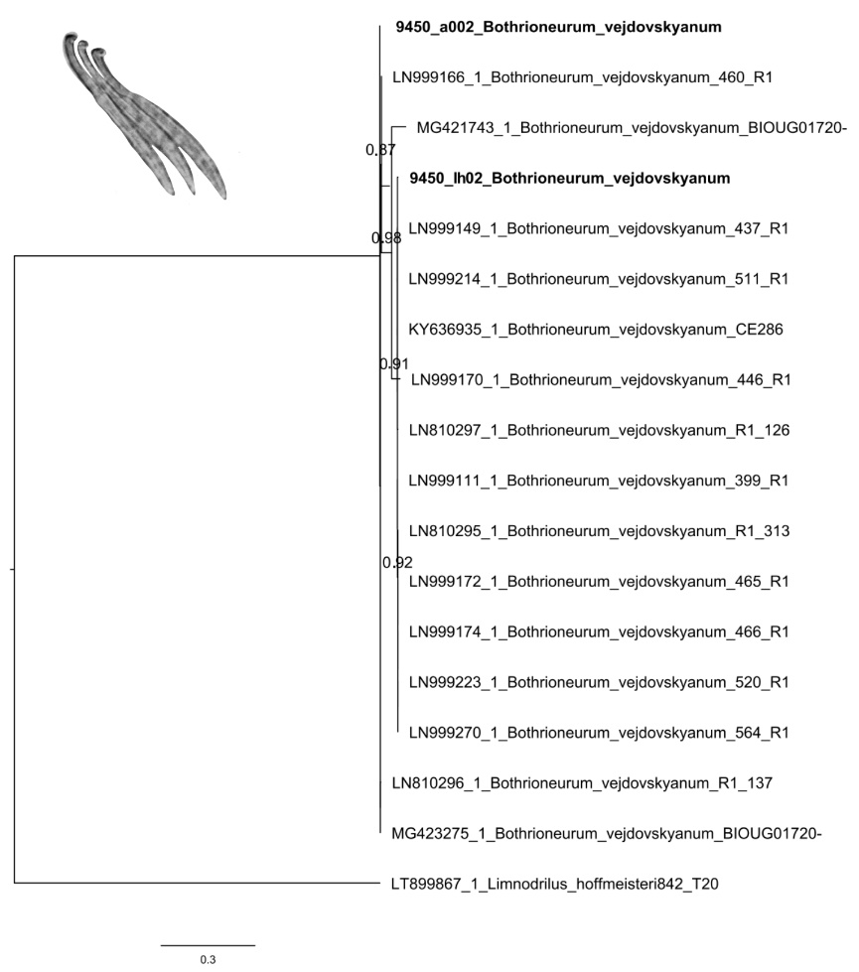
Figure 6. Maximum likelihood phylogenetic tree for the species Bothrioneurum vejdovskyanum, including sequences from GenBank and Limnodrilus hoffmeisteri as an outgroup. The sequences from Lake Maggiore are shown in bold. The image represents penial chaetae.

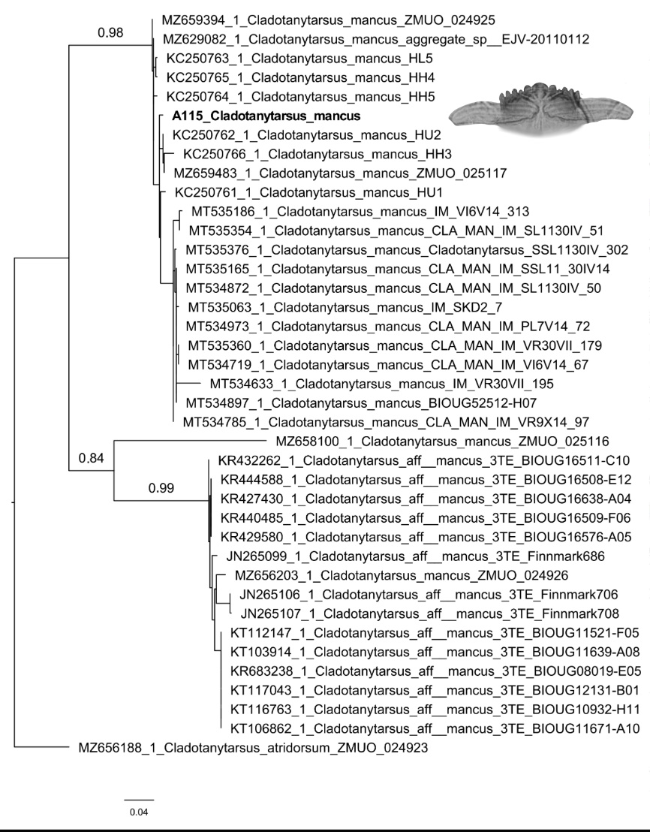
Figure 7. Maximum likelihood phylogenetic tree for the species Cladotanytarsus mancus, including sequences from GenBank and Cladotanytarsus atridorsum as an outgroup. The sequences from Lake Maggiore is shown in bold. The image represents mentum and ventromental plates of Cladotanytarsus sp.

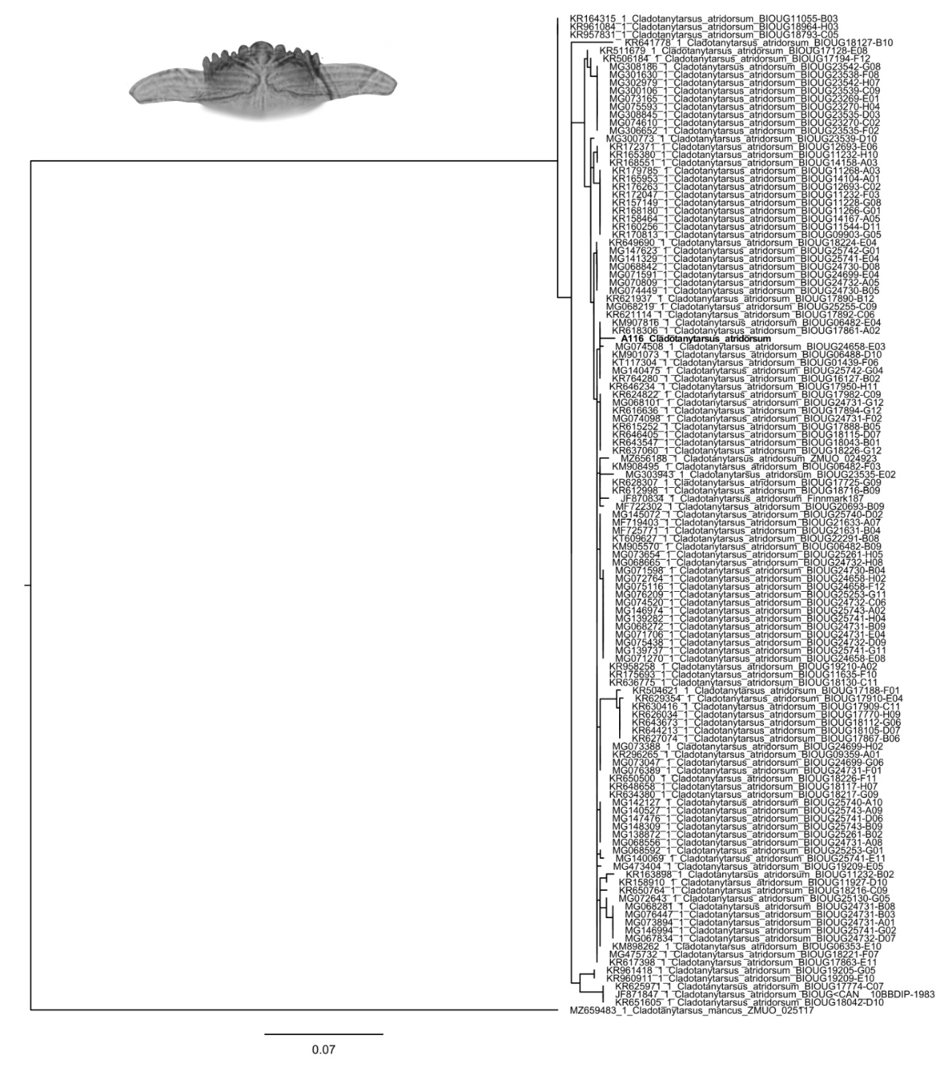
Figure 8. Maximum likelihood phylogenetic tree for the species Cladotanytarsus atridorsum, including sequences from GenBank and Cladotanytarsus mancus as an outgroup. The sequences from Lake Maggiore is shown in bold. The image represents mentum and ventromental plates of Cladotanytarsus sp.
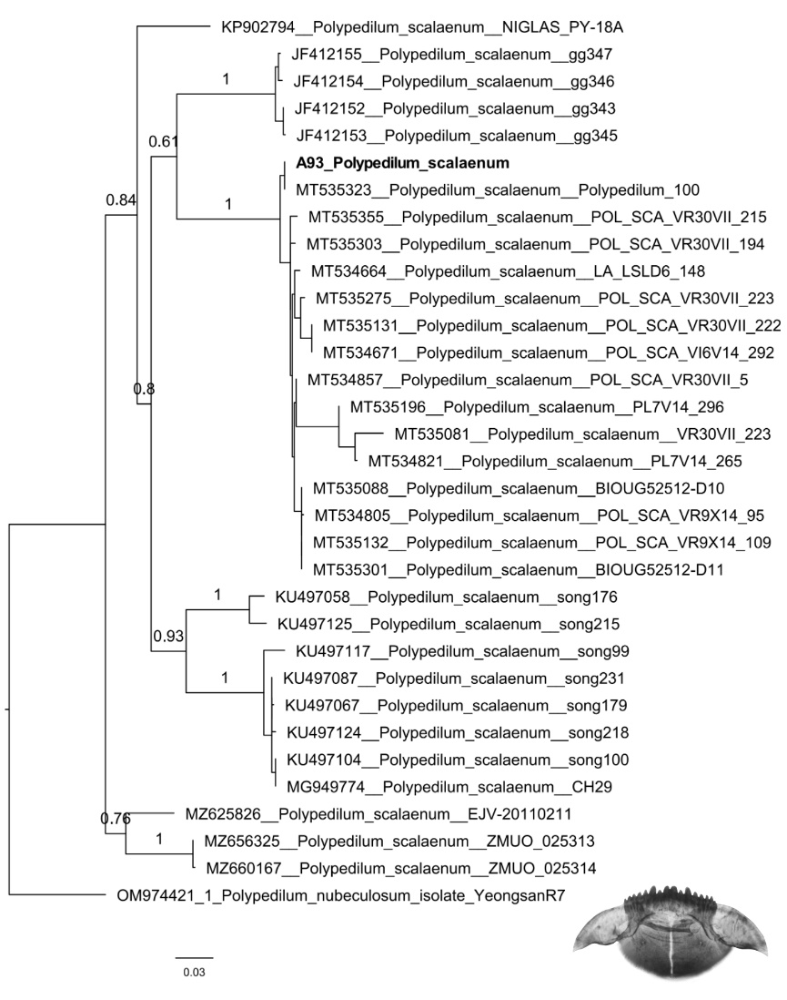
Figure 9. Maximum likelihood phylogenetic tree for the species Polypedilum scalaenum, including sequences from GenBank and Polypedilum nubeculosum as an outgroup. The sequences from Lake Maggiore is shown in bold. The image represents mentum and ventromental plates of Polypedilum sp.

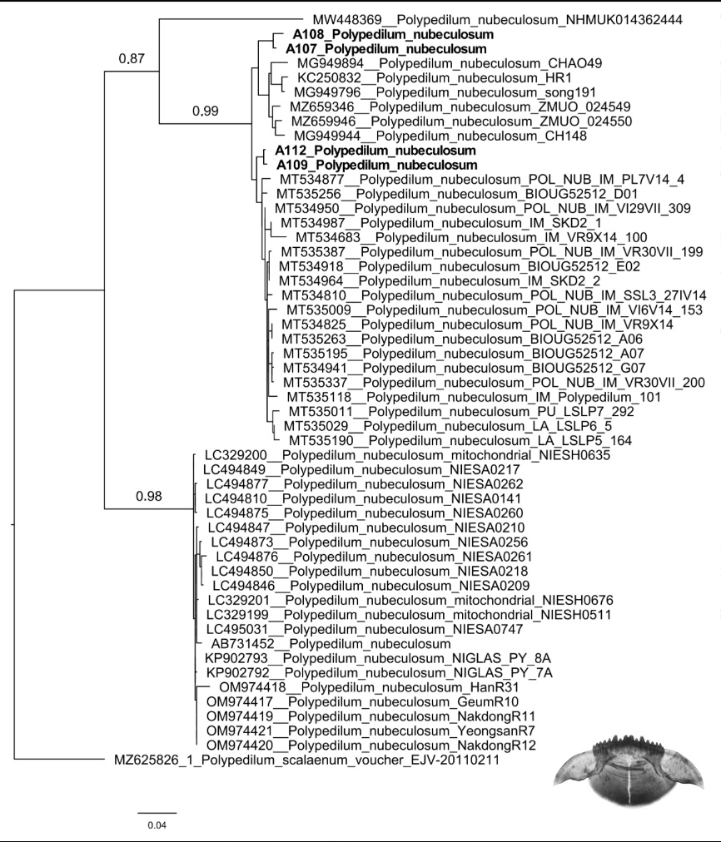
Figure 10. Maximum likelihood phylogenetic tree for the species Polypedilum nubeculosum, including sequences from GenBank and Polypedilum scalaenum as an outgroup. The sequences from Lake Maggiore are shown in bold. The image represents mentum and ventromental plates of Polypedilum sp.

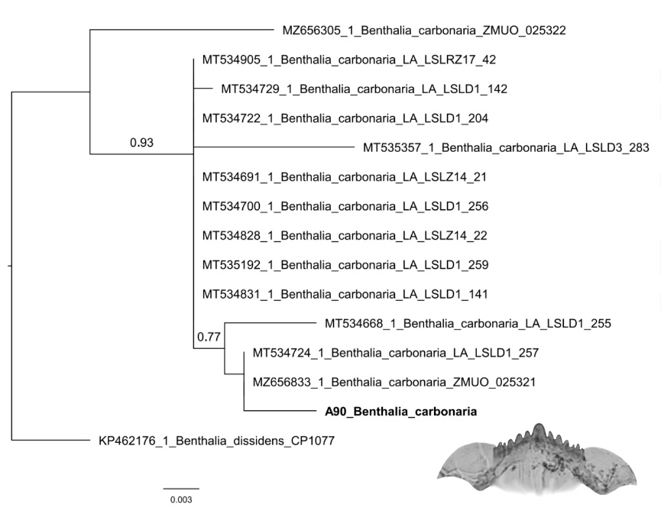
Figure 11. Maximum likelihood phylogenetic tree for the species Benthalia carbonaria, including sequences from GenBank and Benthalia dissidens as an outgroup. The sequences from Lake Maggiore is shown in bold. The image represents mentum and ventromental plates of the species.

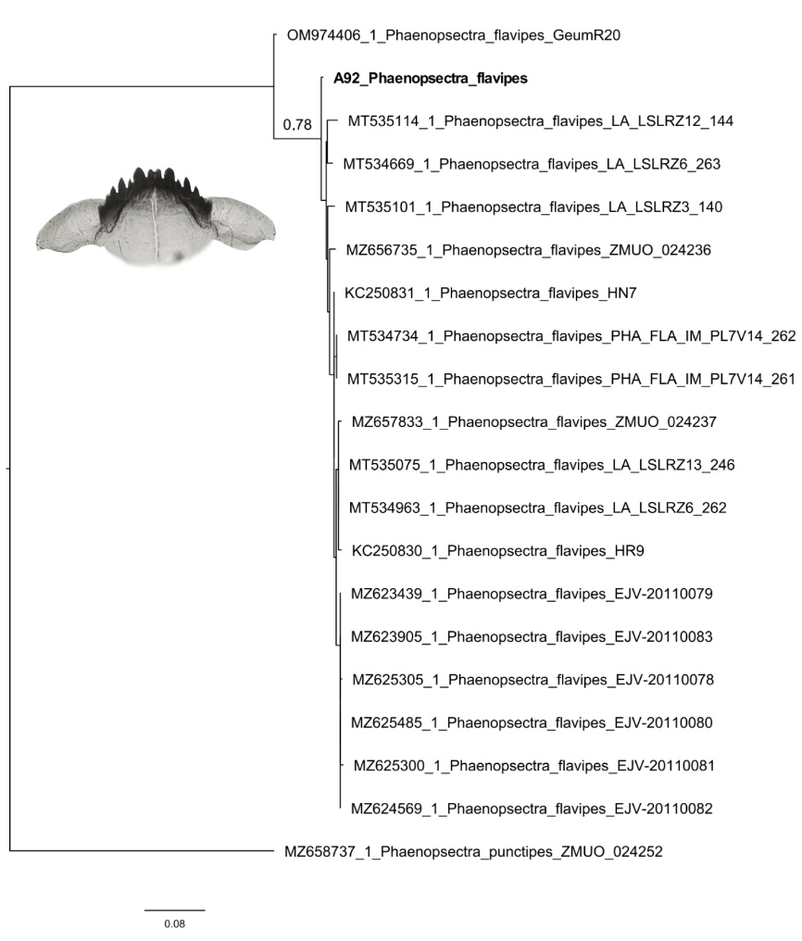
Figure 12. Maximum likelihood phylogenetic tree for the species Phaenopsectra flavipes, including sequences from GenBank and Phaenopsectra punctipes as an outgroup. The sequences from Lake Maggiore is shown in bold. The image represents mentum and ventromental plates of the species.

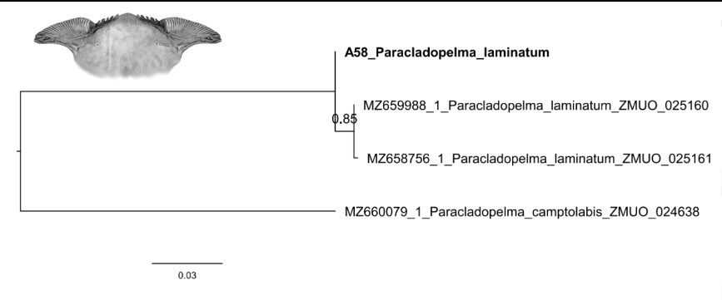
Figure 13. Maximum likelihood phylogenetic tree for the species Paracladopelma laminatum, including sequences from GenBank and Paracladopelma camptolabis as an outgroup. The sequences from Lake Maggiore is shown in bold. The image represents mentum and ventromental plates of the species.

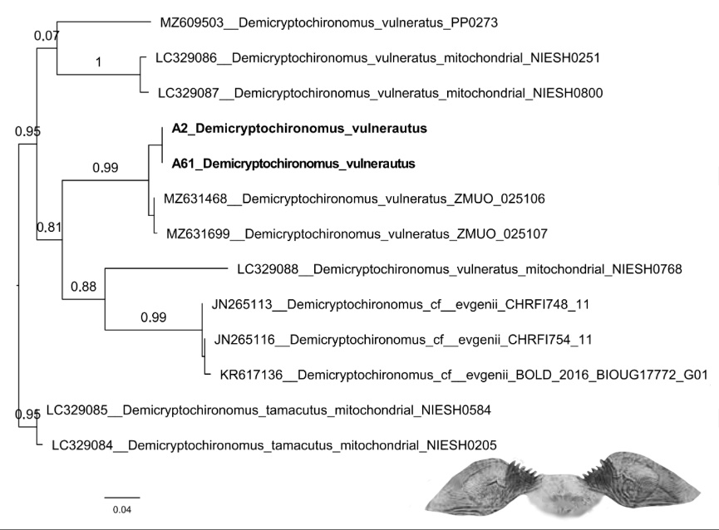
Figure 14. Maximum likelihood phylogenetic tree for the species Demicryptochironomus vulneratus, including all the sequences of the same genus from GenBank. The sequences from Lake Maggiore are shown in bold. The image represents mentum and ventromental plates of the species.

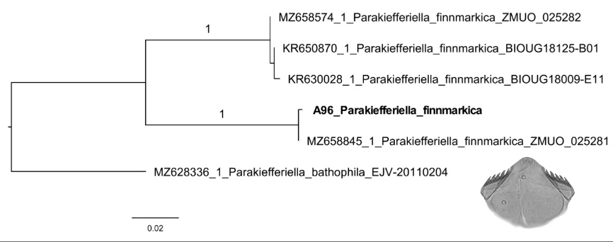
Figure 15. Maximum likelihood phylogenetic tree for the species Parakiefferiella finnmarkica, including sequences from GenBank and Parakiefferiella bathophila as an outgroup. The sequences from Lake Maggiore is shown in bold. The image represents mentum and ventromental plates of the species.

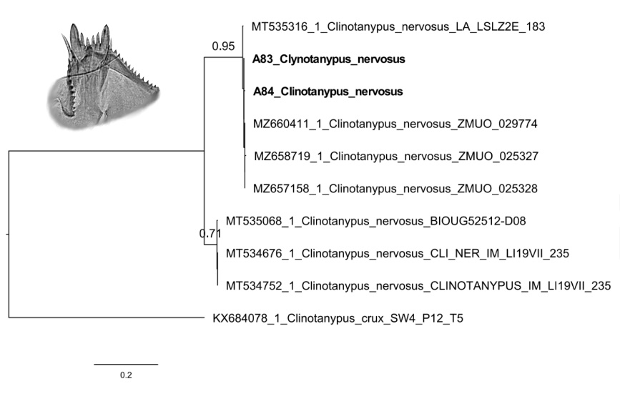
Figure 16. Maximum likelihood phylogenetic tree for the species Clinotanypus nervosus, including sequences from GenBank and Clinotanypus crux as an outgroup. The sequences from Lake Maggiore are shown in bold. The image represents ligula, paraligulae and hypopharyngeal pecten.

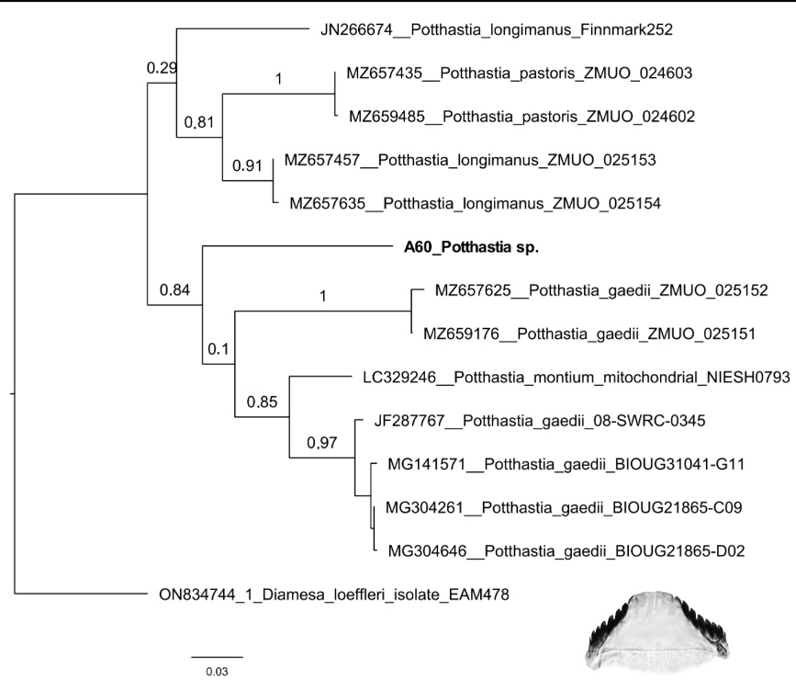
Figure 17. Maximum likelihood phylogenetic tree for the genera Potthastia, including sequences from GenBank and Diamesa loeffleri as an outgroup. The sequences from Lake Maggiore is shown in bold. The image represents the mentum of the animal sequenced from Lake Maggiore.

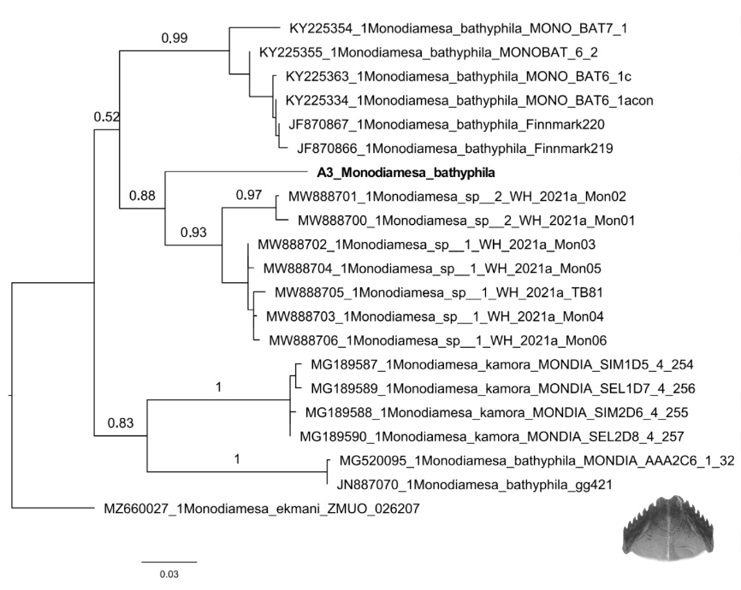
Figure 18. Maximum likelihood phylogenetic tree for the species Monodiamesa bathyphila, including sequences of the same genus from GenBank and Monodiamesa ekmani as an outgroup. The sequences from Lake Maggiore is shown in bold. The image represents the mentum of the species from Lake Maggiore.

